Project Report

1. INTRODUCTION
   1. Overview

An overview of exploring the world's top YouTube channels involves analyzing successful channels to gain insights for content creators, businesses, and marketers regarding effective content strategies, audience engagement, and monetization methods.

* 1. Purpose

The purpose of exploring the world's top YouTube channels is to understand their strategies, audience engagement, and monetization methods, providing insights for content creators, businesses, and marketers to improve their own online presence.

2. PROBLEM DEFINITION & DESIGN THINKING

2.1 Empathy Map

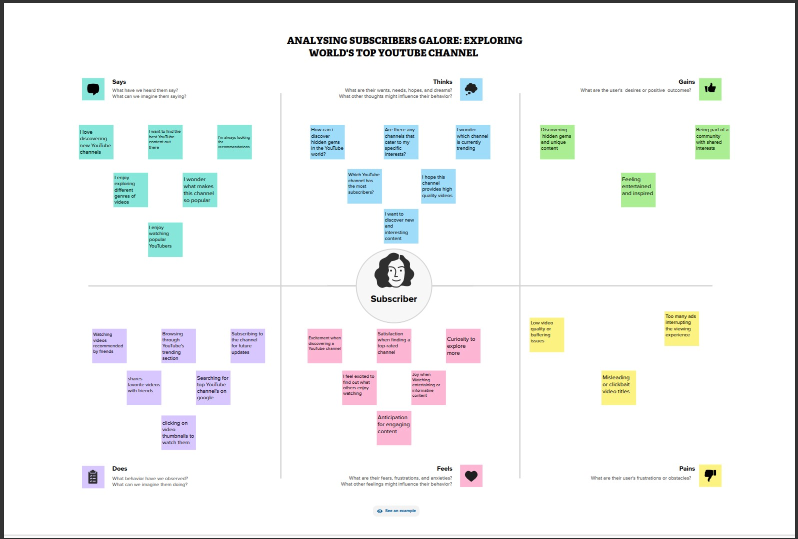

1. Ideation & Brainstorming Map

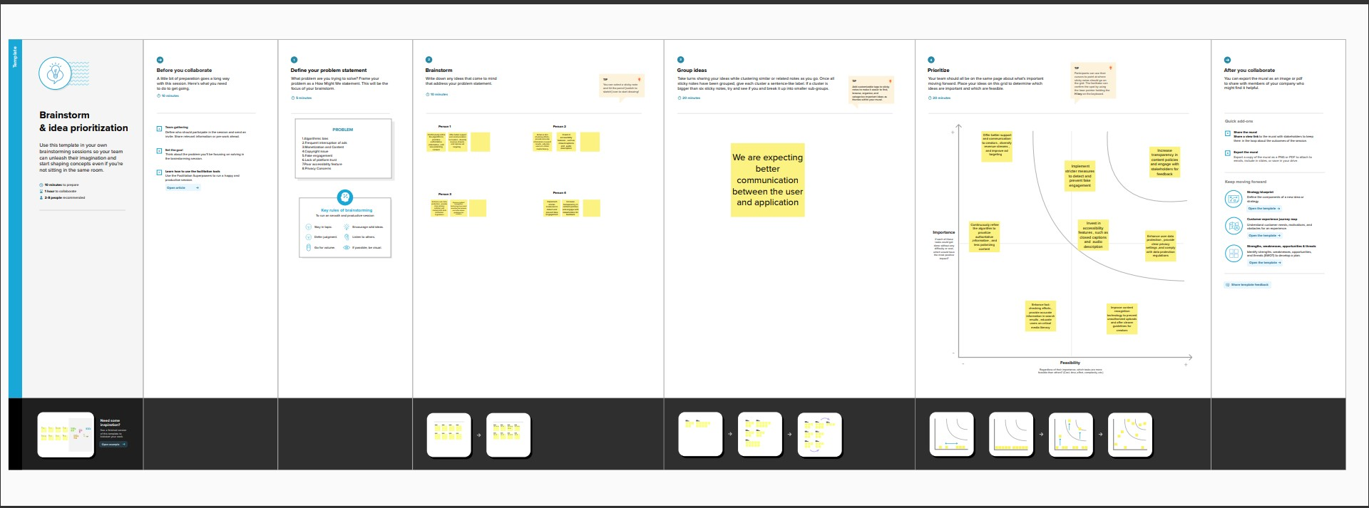

1. RESULT

3.1 Dashboard

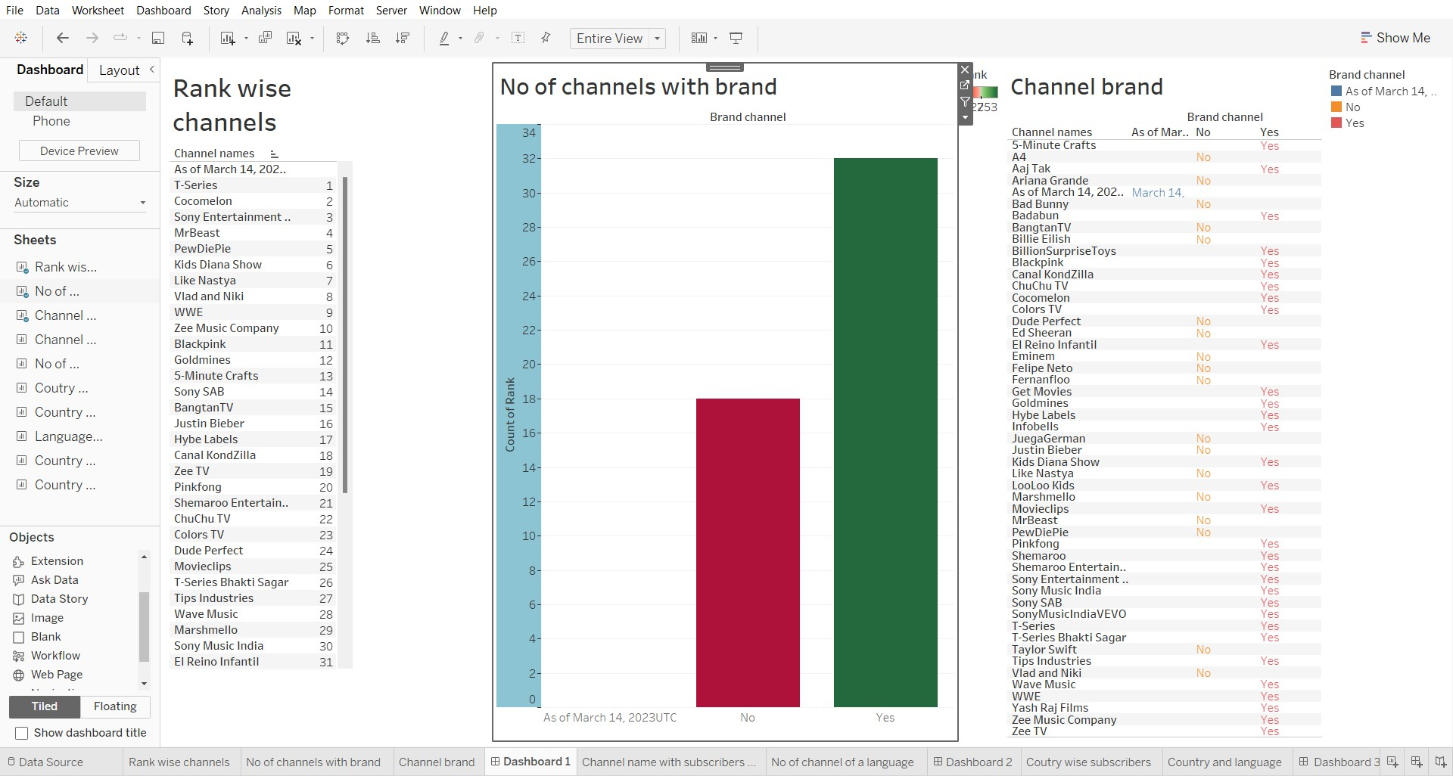

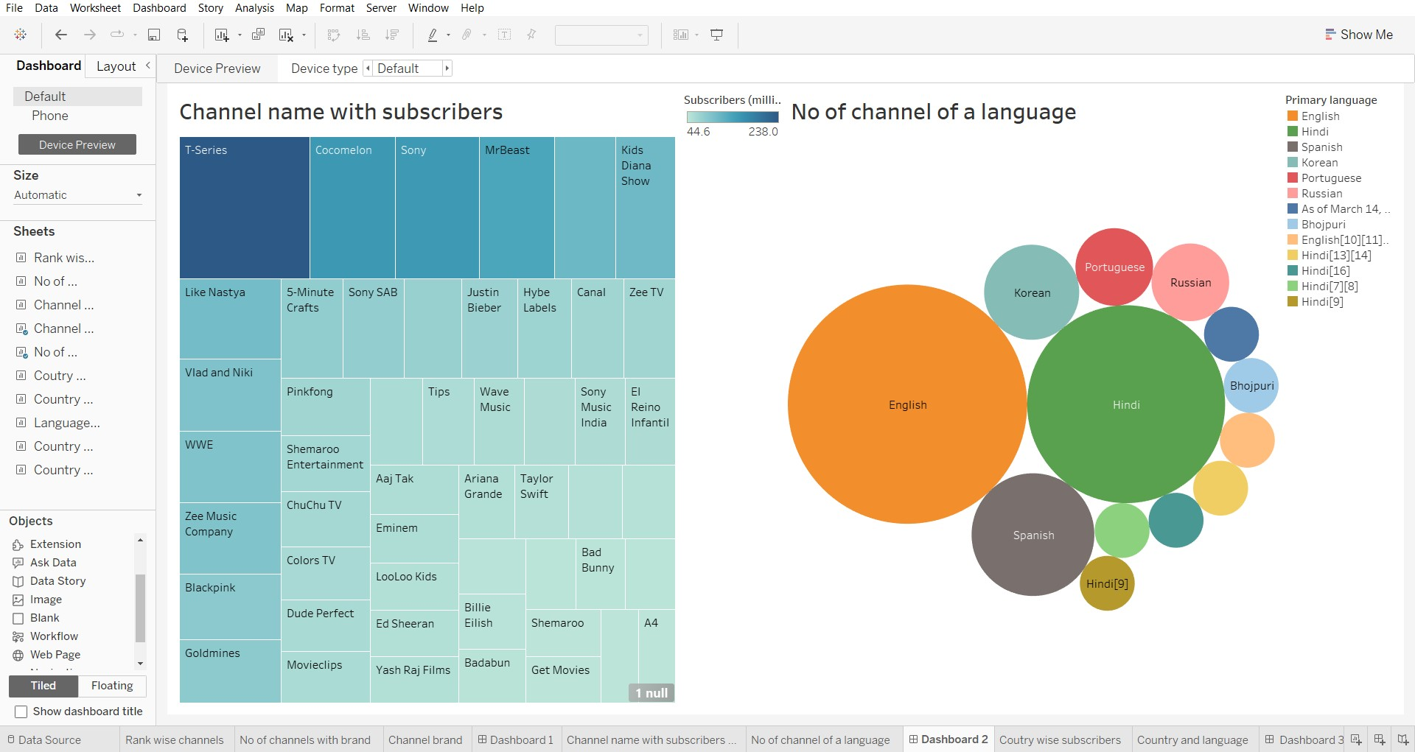

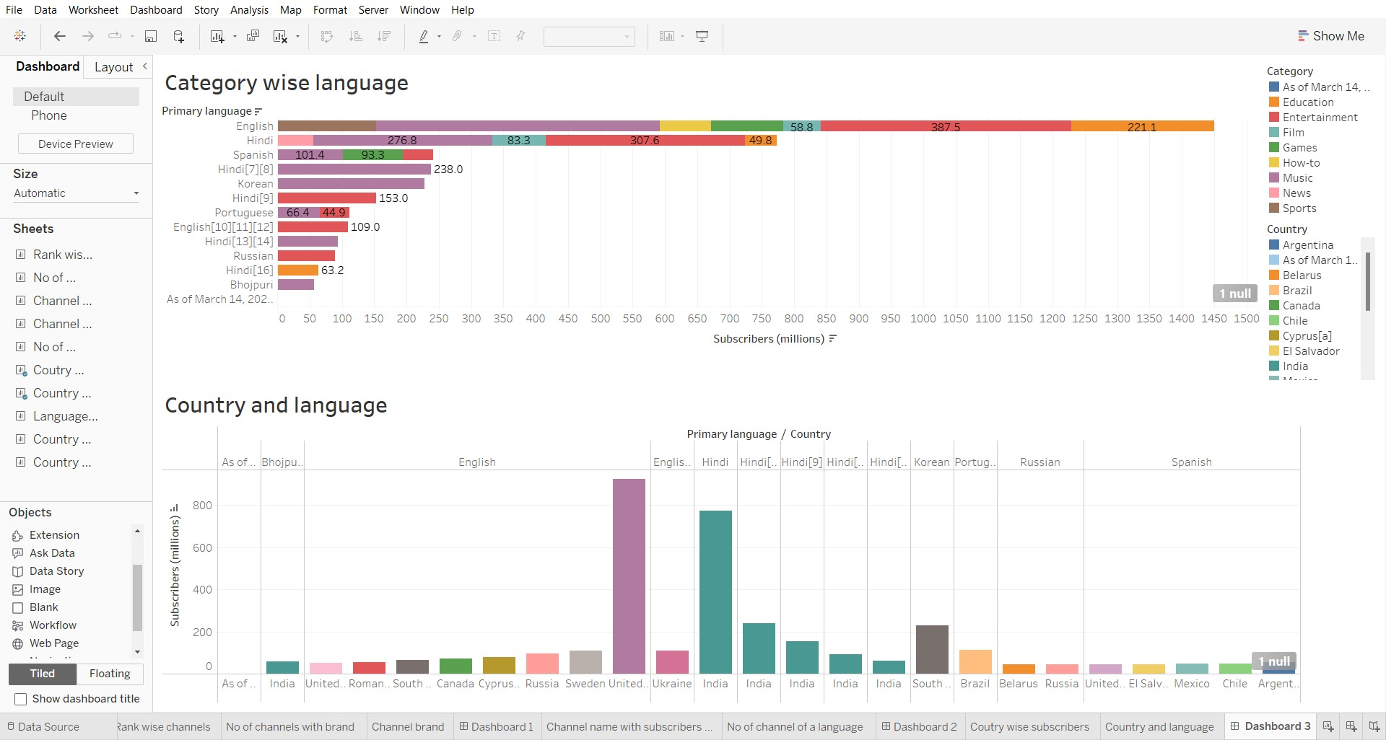

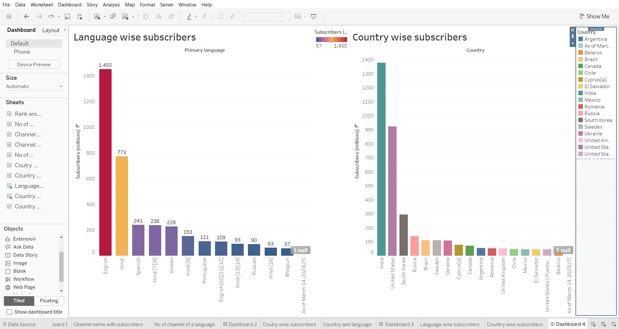

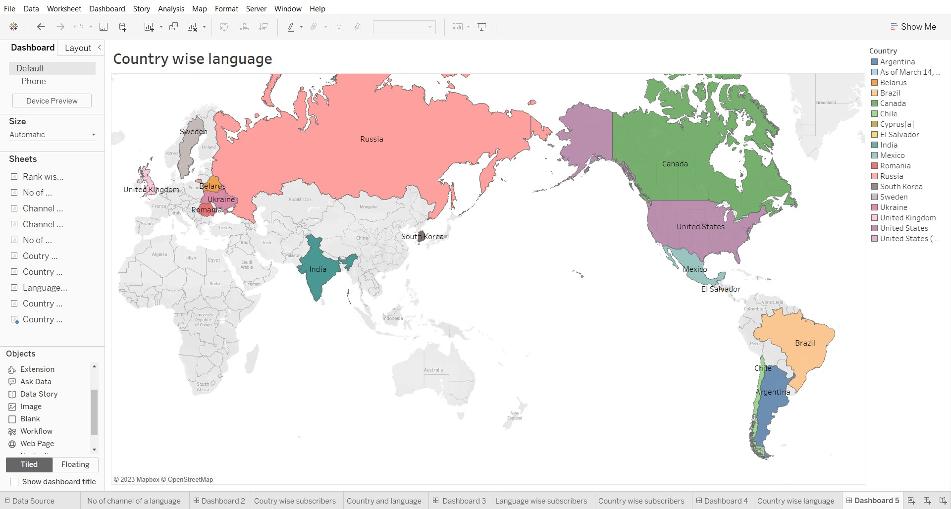

3.2 Stories

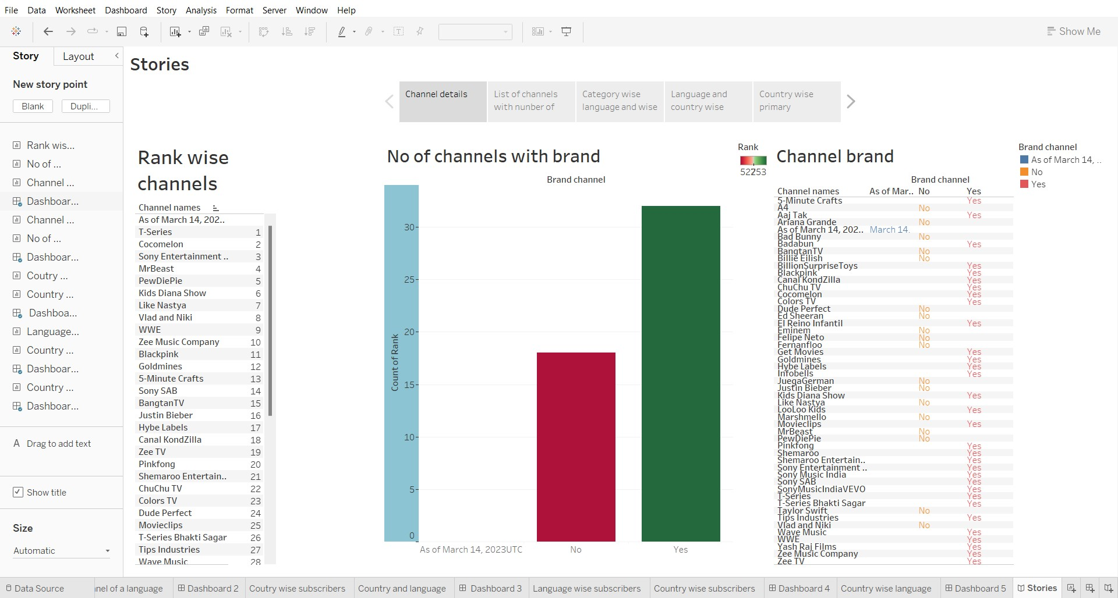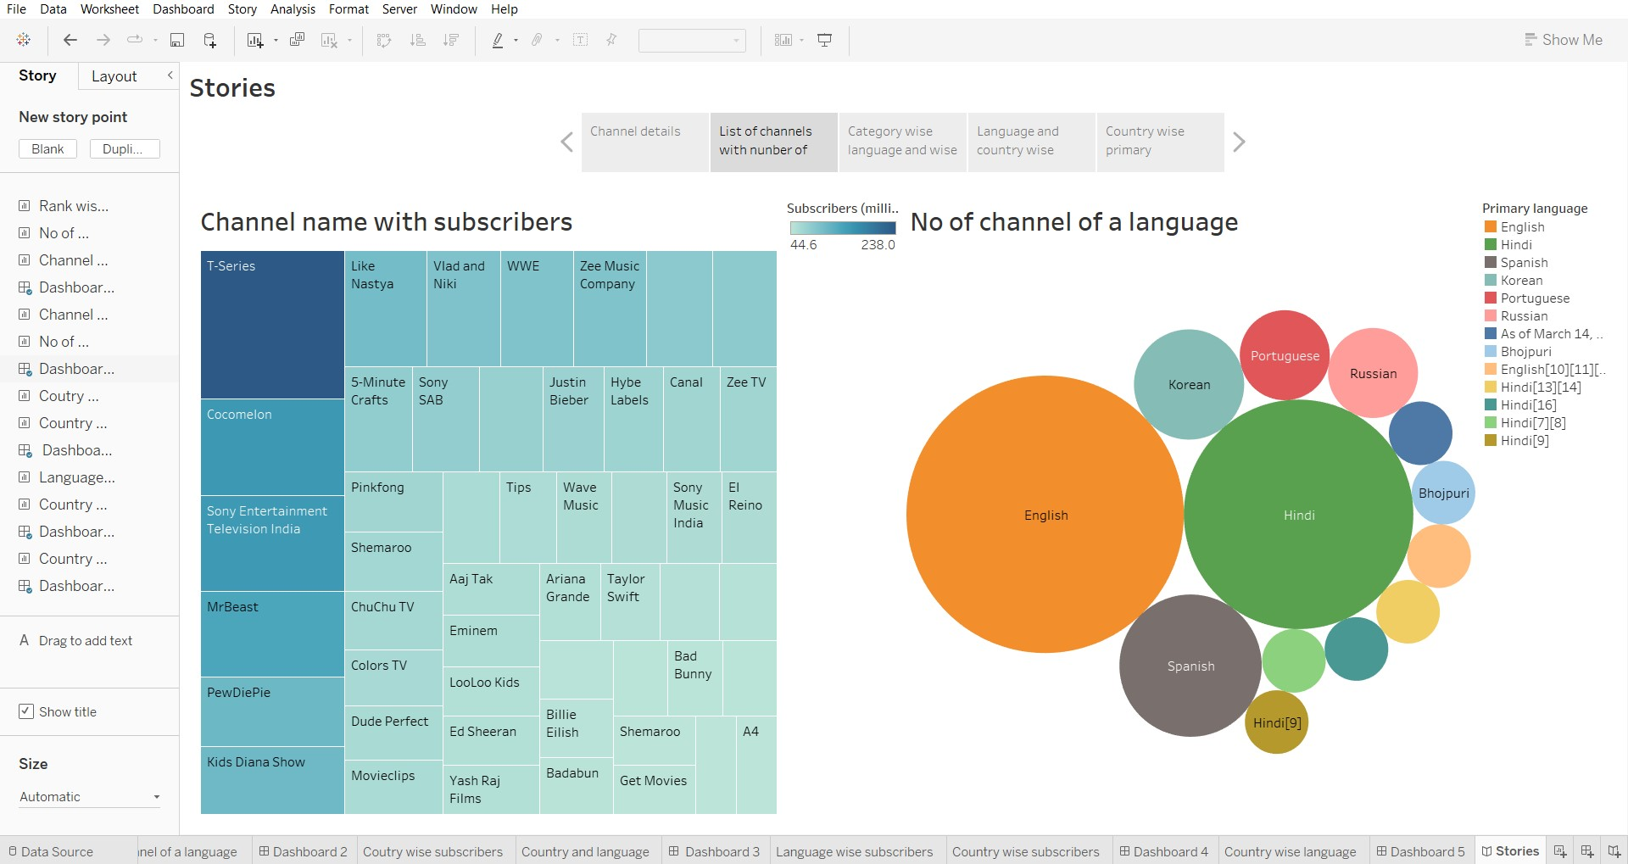

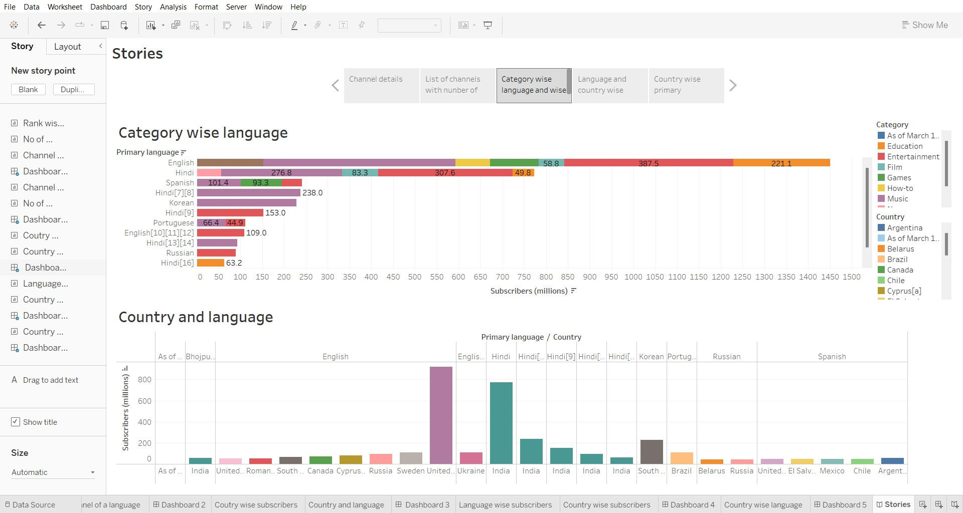

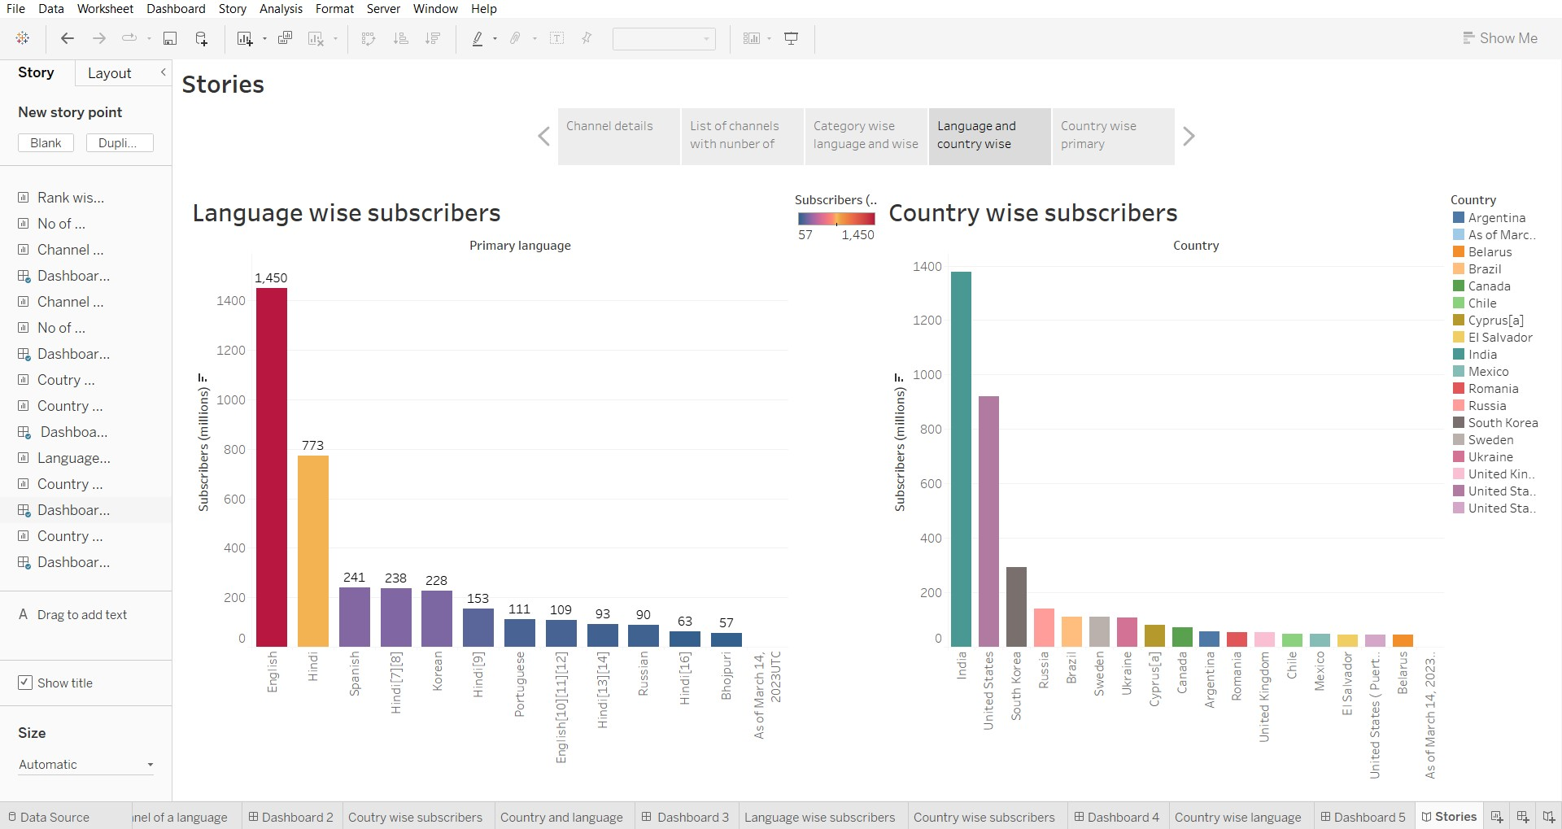

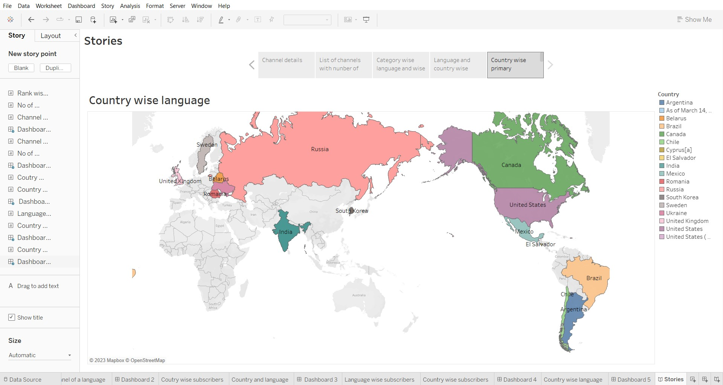

4. ADVANTAGES & DISADVANTAGES Advantages:

Valuable insights for content creators and businesses.

Inspirational for aspiring YouTubers.

Learning opportunities about content strategies and trends.

Informative for market research.

Understanding industry trends.

Disadvantages:

Resource-intensive data collection and analysis.

Constantly changing YouTube landscape.

Limited generalizability to smaller channels.

Ethical considerations regarding privacy and content.

Potential data reliability issues.

1. APPLICATIONS

The application of exploring the world's top YouTube channels includes learning from their success, shaping content strategies, and gaining insights into audience engagement and monetization techniques for content creators, marketers, and businesses.

6. CONCLUSION

As YouTube continues to evolve, our project provides valuable insights for aspiring creators and marketers to thrive in the world of online video content.

7. FUTURE SCOPE

Considering advancements in technology, changing viewer behaviors, and evolving content formats.